Project Planning Phase
Project Planning Template (Product Backlog, Sprint Planning, Stories, Story points)

Date | 9 February 2026
Team ID | LTVIP2026TMIDS61992
Project Name | visualization tool for electric vehicle charge and range analysis
Maximum Marks | 8 Marks

Product Backlog, Sprint Schedule, and Estimation (4 Marks)

Sprint | Functional Requirement (Epic) | User Story Number | User Story / Task | Story Points | Priority | Team Members
Sprint-1 | Registration | USN-1 | As a user, I can register using email and password. | 2 | High | Team
Sprint-1 | Registration | USN-2 | As a user, I receive confirmation after registration. | 1 | High | Team
Sprint-1 | Login | USN-3 | As a user, I can log in using email and password. | 2 | High | Team
Sprint-1 | Web Setup | USN-4 | Set up Flask project structure with templates and static folders. | 3 | High | Team
Sprint-2 | Data Preparation | USN-5 | Clean EV dataset and remove invalid values. | 3 | High | Team
Sprint-2 | KPI Creation | USN-6 | Create KPIs for average range and average price. | 2 | High | Team
Sprint-2 | Visualization | USN-7 | Create EV range comparison charts. | 3 | High | Team
Sprint-3 | Dashboard | USN-8 | Build Tableau dashboard with multiple sheets. | 5 | High | Team
Sprint-3 | Dashboard | USN-9 | Create EV story visualization. | 3 | Medium | Team
Sprint-3 | Integration | USN-10 | Embed Tableau dashboard into web page. | 3 | High | Team
Sprint-4 | UI Features | USN-11 | Add features, FAQ, and contact sections. | 2 | Medium | Team
Sprint-4 | Contact | USN-12 | Add contact form with success notification. | 2 | Medium | Team
Sprint-4 | Finalization | USN-13 | Test the system and fix UI or data issues. | 3 | High | Team
Sprint-4 | Deployment | USN-14 | Prepare final submission files and documentation. | 2 | High | Team

Project Tracker, Velocity & Burndown Chart: (4 Marks)
Sprint | Total Story Points | Duration | Sprint Start Date | Sprint End Date (Planned) | Story Points Completed | Sprint Release Date (Actual)
Sprint-1 | 8 | 6 Days | Day 1 | Day 6 | 8 | Day 6
Sprint-2 | 8 | 6 Days | Day 7 | Day 12 | 8 | Day 12
Sprint-3 | 11 | 6 Days | Day 13 | Day 18 | 11 | Day 18
Sprint-4 | 9 | 6 Days | Day 19 | Day 24 | 9 | Day 24

Velocity:
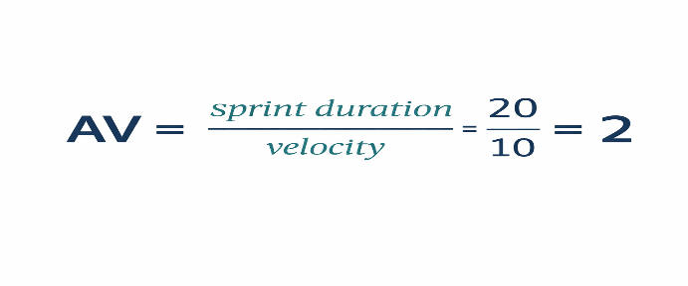
Burndown Chart:
